**Demo Eager Fetching**

**Demo Eager Fetching (Step-by-Step)**:

1. Modify the Instructor class
2. Debug Main App for test

**1) Modify the Instructor class**:

We know that Instructor have a list of courses. Set up “FaceType” here for the courses to be eager.

@OneToMany(fetch=FetchType.***EAGER***, mappedBy = "instructor",

cascade = { CascadeType.***PERSIST***, CascadeType.***MERGE***,

CascadeType.***DETACH***,CascadeType.***REFRESH*** })

**private** List<Course> courses;

Basically, we load the Instructor and also load the Courses at the same time.

**2) Debug Main App for test**:

Now for test our main app we set a breakpoint in “EagerDemo.java” class.

Right Click on the line -> Toggle Breakpoint

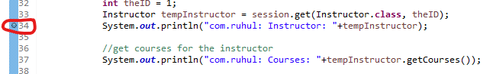

Now we run the application as Debug Mode

Run -> Debug As -> Java Application

Now Eclipse open “Debug Perspective”



In the console we will see our App load the Instructor and InstructorDetail.

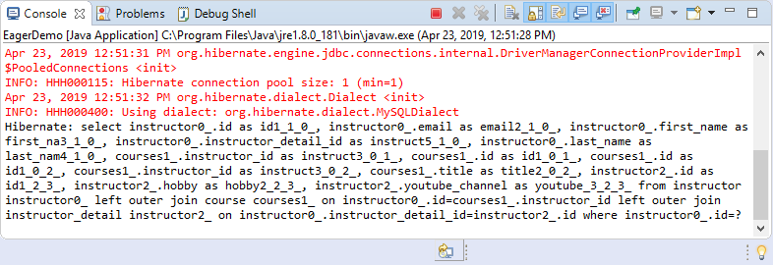

Actually, at this point everything is loaded: Instructor, InstructorDetail, and Courses. No need to hit the database. Everything is load in the memory at first time. For show more information hit the “Step Over” button.



In Eager loading all data loaded in the memory at First time.

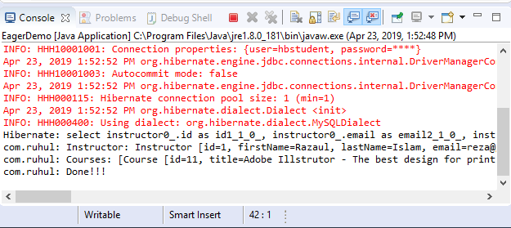

In the above picture we will show our application hit the database at first time only.

**File: EagerDemo.class**:

**package** com.ruhul.odduu.hibernate.demo;

**import** org.hibernate.Session;

**import** org.hibernate.SessionFactory;

**import** org.hibernate.cfg.Configuration;

**import** com.ruhul.odduu.hibernate.entity.eager.Course;

**import** com.ruhul.odduu.hibernate.entity.eager.Instructor;

**import** com.ruhul.odduu.hibernate.entity.eager.InstructorDetail;

**public** **class** EagerDemo {

**public** **static** **void** main(String args[]) {

// create session factory

SessionFactory factory = **new** Configuration()

.configure("hibernate.cfg.xml")

.addAnnotatedClass(Instructor.**class**)

.addAnnotatedClass(InstructorDetail.**class**)

.addAnnotatedClass(Course.**class**)

.buildSessionFactory();

// create session

Session session = factory.getCurrentSession();

**try** {

// start transaction

session.beginTransaction();

// get the instructor from DB

**int** theID = 1;

Instructor tempInstructor = session.get(Instructor.**class**, theID);

System.***out***.println("com.ruhul: Instructor: "+tempInstructor);

//get courses for the instructor

System.***out***.println("com.ruhul: Courses: "+tempInstructor.getCourses());

// commit the transaction

session.getTransaction().commit();

System.***out***.println("com.ruhul: Done!!!");

} **finally** {

// add clean up code

session.close();

factory.close();

}

}

}

Demo Eager Fetching